INVENTION DISCLOSURE FORM FOR PATENTS

Applicant Name-Marwadi University

- Particulars of Inventors
Mr./Ms/Dr. | Name (Full) | Department | Designation | Mobile No. | Email | Postal Address
Mr. | Yash Talaviya | Computer Engg. | Student | 9408866115 | yash.talaviya131309@marwadiuniversity.ac.in | Marwadi University - Rajkot
Mr. | Tirth Bhut | Computer Engg. | Student | 7863078371 | tirth.bhut131162@marwadiuniversity.ac.in | Marwadi University - Rajkot
Mr. | Pratham Gajra | Computer Engg. | Student | 9924644667 | pratham.gajra131330@marwadiuniversity.ac.in | Marwadi University - Rajkot
Prof. | Yogeshwar Prajapati | Computer Engg. | Asst. Professor | 9898260380 | yogeshwar.prajapati@marwadieducation.edu.in | Marwadi University - Rajkot

- Provide title of the invention: In 100 words or less, please provide an abstract or summary of the invention:
Title : EMAIL SPAM DETECTION USING MACHINE LEARNING
Abstract : Email spam is a major cybersecurity issue that leads to phishing attacks, malware distribution, and
information theft. This project focuses on detecting spam emails using Machine Learning techniques.
The system analyzes email content, subject lines, and metadata to classify emails as spam or legitimate
(ham). Text preprocessing techniques such as tokenization and feature extraction are applied before
training ML models. Algorithms like SVM, Naïve Bayes and Logistic Regression are used to achieve
accurate classification. The proposed solution helps improve email security by detect malicious emails,
thereby protecting users from cyber threats and improving communication efficiency

- Detail description of the invention:
  - Problem the invention is solving:
Email communication is widely used, but it is highly vulnerable to spam and phishing attacks. Existing systems either rely on rule-based filters or slower machine learning models, which fail to adapt to new patterns or take too much time for real-time detection. Additionally, many systems do not provide confidence levels, making it difficult to assess prediction reliability. There is a need for a fast, accurate, and adaptive system that can detect spam emails efficiently.

  - General Utility/application of the invention:
- Corporate email security systems
- Cybersecurity tools for phishing detection
- Web applications for spam filtering
- Real-time messaging platforms
  - Advantages of the invention disclosing about the increased efficiency:
- High accuracy (~98%) compared to traditional models
- Fast execution suitable for real-time use
- Provides confidence score for each prediction
- Reduced false positives and false negatives
- Scalable for large datasets
- Simple and efficient implementation

  - Best way of using the invention as well as possible variants :
- Best usage:
  - Integrate into email servers as a filtering system
  - Use as API for real-time classification
- Variants:
  - Can be extended with Deep Learning (LSTM/BERT)
  - Can include URL analysis and metadata features
  - Can be deployed as mobile/web application
  - Working of invention along with Drawing, schematics and flow diagrams if required with complete explanations:
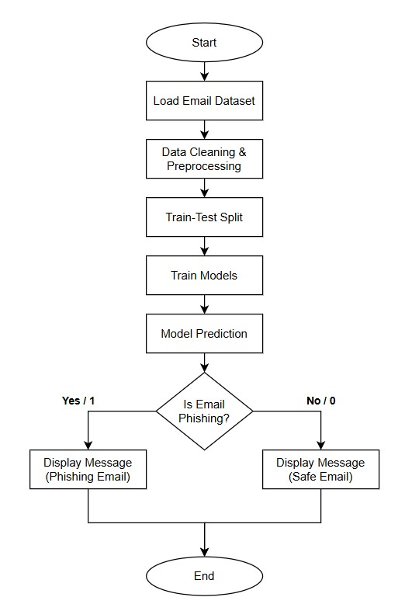
Figure 3.1 FlowChart
- Load email dataset
- Perform data cleaning:
  - Remove unwanted columns
  - Handle missing values
- Preprocess text:
  - Convert to lowercase
  - Remove URLs and special characters
  - Remove extra spaces
- Apply TF-IDF vectorization
- Split dataset into training and testing
- Train model using LinearSVC
- Apply calibration for probability output
- Evaluate using:
  - Accuracy
  - Precision
  - Recall
  - F1-score
- Input new email
- Predict:
- Spam or Ham
- Confidence score
- Have you conducted a Primary Patent Search? Yes / No (if yes, attach the patent search results)
No

- List out the known ways about how others have tried to solve the same or similar problems? Indicate the disadvantages of these approaches. In addition, please identify any prior art documentation or other material that explains or provides examples of such prior art efforts

S. No. | Existing state of art | Drawbacks in existing state of art | Overcome (how your invention is overcoming the drawback)
1 | Rule-based keyword filtering (Blacklists, regex pattern matching) | Easily evaded by spammers using obfuscation, misspellings, and synonyms; high false-positive rates; require constant manual updates | ML-based TF-IDF + LinearSVC learns patterns automatically; handles obfuscation naturally; no manual rule updates needed
2 | Naive Bayes classifier using Bag-of-Words | Ignores word order and context; poor on short/ambiguous emails; assumes word independence which is unrealistic | LinearSVC with TF-IDF captures term importance and distributional patterns; meta-features add contextual signals beyond pure word frequency
3 | Single-model SVM or Random Forest on text-only features | Text-only features miss structural email cues (punctuation density, URL count, caps ratio); SVM lacks calibrated probability output | Our hybrid system extracts meta-features alongside TF-IDF; CalibratedClassifierCV adds reliable confidence scores for each prediction
5 | Deep Learning (CNN/LSTM/BERT) for spam detection | Requires massive labeled datasets; computationally expensive; slow training (hours); not practical for real-time deployment | LinearSVC + CalibratedClassifierCV trains in under 4 minutes; achieves 98.27% accuracy comparable to DL models with fraction of computation

- List the Technical features and Elements of the invention along with the Description of your invention from start to end.:
- Text preprocessing module :
This module is responsible for cleaning and preparing raw email data before it is used for model training. It converts all text to lowercase, removes unwanted elements such as URLs, special characters, and extra spaces. This step ensures that the input data is consistent and noise-free, improving the overall performance of the model.

- TF-IDF feature extraction :
The Term Frequency–Inverse Document Frequency (TF-IDF) technique is used to convert textual email content into numerical form. It assigns importance to words based on their frequency in a document relative to the entire dataset. This helps the model focus on meaningful words while ignoring common but less informative terms.

- Linear Support Vector Classifier :
This is the core classification algorithm used in the system. It analyzes the numerical features generated by TF-IDF and classifies emails into spam or ham categories. LinearSVC is chosen because of its high accuracy and fast processing capability, making it suitable for real-time applications.

- Calibration module (for probability output) :
This module enhances the classifier by converting its output into probability scores. It provides a confidence level for each prediction, indicating how certain the model is about classifying an email as spam or safe. This improves decision-making and increases reliability.

- Model evaluation system :
This component evaluates the performance of the trained model using metrics such as accuracy, precision, recall, and F1-score. It also generates a confusion matrix to visualize correct and incorrect predictions. This helps in validating the effectiveness of the system.

- List out the features of your invention which are believed to be new and distinguish them over the closest technology.
- LinearSVC with Probability Calibration
The model combines LinearSVC with CalibratedClassifierCV to provide probability-based predictions, improving confidence and reliability over traditional SVM models.

- TF-IDF Feature Extraction
Uses TF-IDF to convert email text into numerical form, capturing the importance of words instead of relying on simple keyword matching.

- Additional Textual Features
Includes features like email length and punctuation count to improve detection of hidden spam patterns.

- High Accuracy Performance
Achieves 98.27% accuracy with strong precision and recall, making it more effective than many existing methods.
- Robust Text Preprocessing
Applies cleaning steps such as removing URLs, special characters, and noise to improve data quality and model performance.

- Machine Learning-Based Adaptability
Unlike rule-based systems, the model adapts to new and evolving spam patterns automatically.

- Scalable System Design
Capable of handling large volumes of email data efficiently, suitable for real-world applications.

- Comprehensive Evaluation Metrics
Uses multiple evaluation methods (accuracy, precision, recall, F1-score, confusion matrix) to ensure reliable performance.

- Has the invention been built or tested or implemented? If yes please provide the Efficiency/Efficacy details of the invention

Yes, the invention has been successfully built, tested, and implemented as part of a machine learning project.
The system was trained on a dataset of 18,650 emails, containing both safe and phishing emails. After preprocessing and training, the model was evaluated using standard performance metrics.

The results show high efficiency:
- Accuracy: 98.27%
- Precision: 0.99 (Ham), 0.98 (Spam)
- Recall: 0.98 (Ham), 0.98 (Spam)

- Briefly state when and how you first conceived this idea?

The idea for this invention was conceived during the development of a Semester 6 mini project in Computer Engineering.

The motivation came from observing the rapid increase in spam and phishing emails in daily communication and the limitations of existing filtering methods. After studying the problem and reviewing existing solutions, the idea of using machine learning techniques for automatic email classification was developed.

The concept was further refined through academic research, experimentation with different models, and implementation using real-world datasets.

- Include any reasons that your invention would not have been obvious to someone of average skill in the art.
The proposed invention is not obvious to a person having average skill in the field because it combines multiple techniques in an optimized and effective manner to achieve high performance.
Firstly, the integration of TF-IDF feature extraction with LinearSVC and CalibratedClassifierCV is not a basic implementation, as it enhances both classification accuracy and provides probability-based confidence scores, which are not available in standard SVM models.
Secondly, the invention improves traditional spam detection by incorporating additional textual features such as email length and punctuation patterns, enabling better identification of complex spam structures beyond simple keyword matching.
Furthermore, the system achieves a high accuracy of 98.27%, which indicates careful tuning of preprocessing steps, feature engineering, and model selection. This level of optimization is not straightforward and requires experimental validation.
Lastly, the invention provides a scalable and adaptive machine learning approach, unlike conventional rule-based systems, making it more effective in handling evolving spam techniques.
These combined improvements make the invention technically advanced and non-obvious compared to existing methods.
- Additional comments by the inventor (if you want to give more details out of scope of this IDF).
This invention provides a practical and scalable solution for email spam detection using machine learning. It demonstrates how proper data preprocessing, feature extraction, and model selection can significantly improve performance.

The system also has strong potential for future development, such as:
- Integration into real-time email systems
- Use of advanced machine learning or deep learning models
- Deployment as a web-based or API-based service

Overall, the invention serves as a strong foundation for further research and real-world implementation.

- Drawings/Flowchart/Table
Table 13.1 Summary Table:
Step | Description
Input | Email text data
Preprocessing | Cleaning and formatting text
Feature Extraction | TF-IDF conversion
Model | LinearSVC + Calibration
Output | Spam or Ham classification

Table 13.2 Comparision Table
Model | Accuracy | Training Time
LinearSVC + CalibratedClassifierCV (Hybrid) on larger dataset | 98.27% | ~4 minutes
LinearSVC alone (Fast Mode) on larger dataset | 97.81% | ~90 seconds
SVM on smaller dataset | 96.88% | ~60 seconds
Random Forest on smaller dataset | 96.56% | ~60 seconds

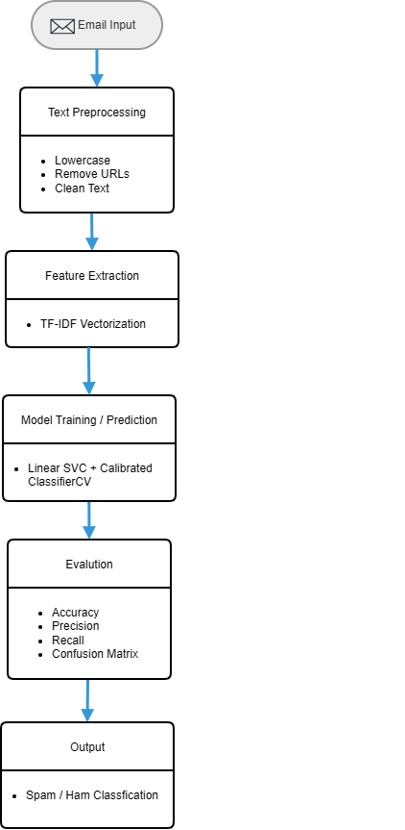
Figure 13.1 Workflow

